Motivators: The Power Motivator

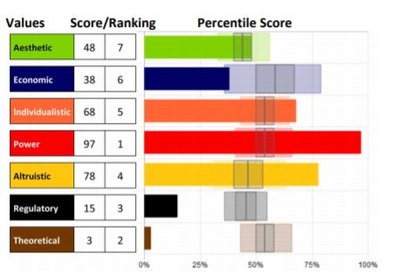
Knowing our specific level of
motivation can be crucial to
helping us understand what
drives our beliefs and actions so
we can bring them into
alignment.

Remember that although we can explore each motivation individually, they cannot be separated.
They can only be distinguished; however, all motivators integrate to
influence us.

The Power Motivator - the drive to be in control or have influence

This is about being a leader, and to have influence and control
over one’s environment or success.

Competitiveness and control are often associated with a high score in
this motivation. This is the need to be seen as a leader and be in
charge and have authority greater or equal to responsibility.

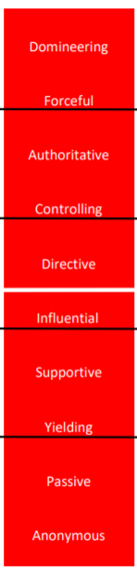
Using this descriptor scale, you can identify a key component to each person’s score in this motivation, as well as see how the scores range from Very Low to Very High, noted by the black lines between each set of descriptors. Each word represents 10 points of 100 on the scale (example: Yielding people score between 20-29, Forceful people score between 80-89 in this dimension).
The white line indicates 50%, perfect balance between high and low in the motivation. Those who score closer to 50% will be situational in applying this motivator. Moving further from that line (high or low) indicates which areas are the more influential.

Whether scores are high or low, the motivators with the furthest distance above or below 50% (above or below “perfect balance” in the center) will be the highest influencers leading to the greatest impact on the decisions being made.

Strengths and Limitations
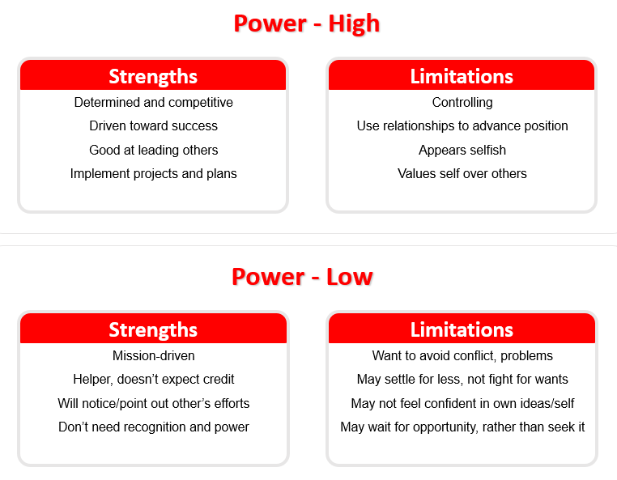

- What drives you in this motivation?
- How can that be helpful and productive for you?
- How can that limit you?

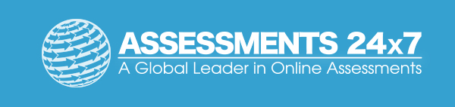Assessments 24x7 LLC 5927 Balfour Court, Ste. 103 Carlsbad, California 92008 USA (206) 400-6647

